**National University of Sciences and Technology (NUST)**

**SE-320 Formal Methods**

Assignment 3

Uppaal

Submitted By:

Khalid .

126131

Github Link:

**Question No: 1**

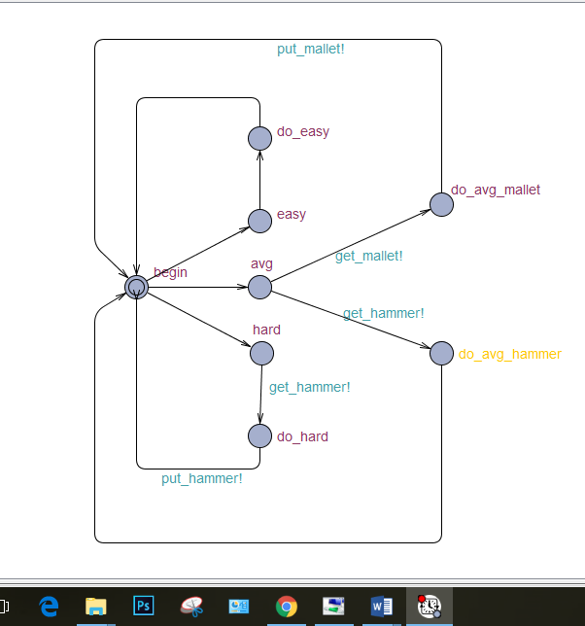

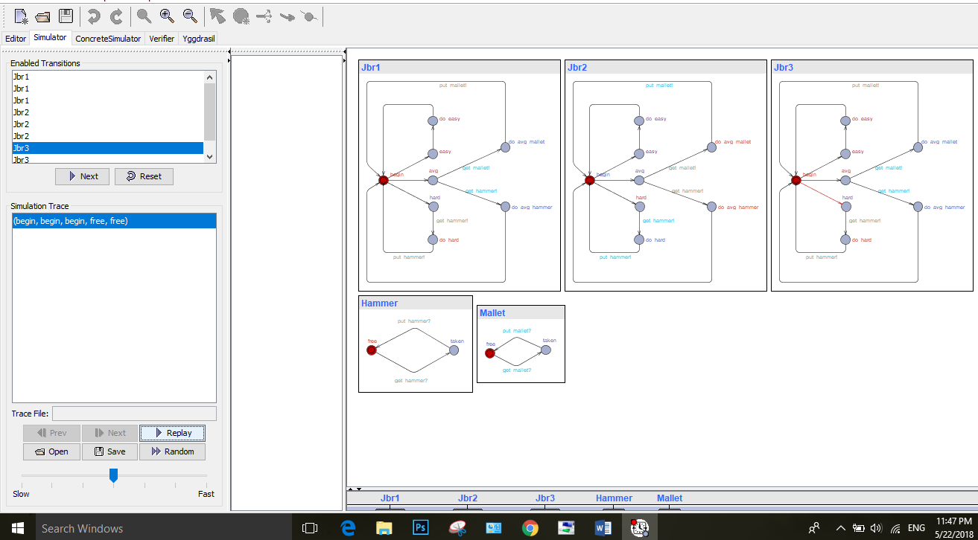

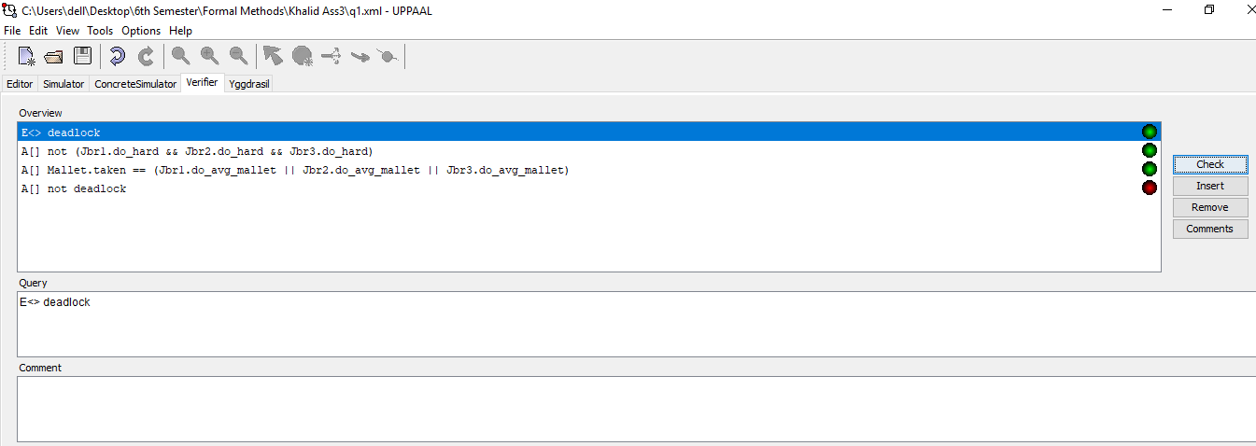

**Question No:2**

